**Final Report:**

**San Francisco**

**Bike Sharing Usage Analysis**

Dec. 2019

Abhishek Damera

Michael Huang

Ming Yu Chi

Moraldeepsingh Sachdeo

Sean Chuang

### Introduction

Bike sharing is a trend in the major cities in the US. These shared bikes decrease pollution in the city and provides flexible short distance travel. However, according to bike sharing usage data provided by SFMTA, average trip is less than 4000 per day considering 262 stations already set up in San Francisco[1]. We would like to analyze how different factors (e.g. weather, weekend, demographic, nearby functionalities affect the usage of bike sharing). With the analysis, we hope to provide insight for bike sharing operations management and also a use case for other cities interested in adopting similar programs.

**Impact**

The bicycle docking station needs optimization since many a times, the station is at its peak capacity in the areas where docking is needed. The inflow in these areas such as Mall tends to be much greater than outflow since people tend to uber back causing bike docking area to be full but identifying these areas can be crucial in order to improve its efficiency. By this analysis: We plan to answer these questions: What is the average duration of a trip? Does it vary by cities? Does it vary by the day of the week or the time of the day? Does weather and demographic characteristics impact the number of trips taken?

This report summarized some of the data modeling and analysis results associated with San Francisco bike sharing data obtained from Kaggle as well as additional feature data. Our overall goal for this project is to know are the following:

1. Predict the number of station-based bike trip patterns vary by day-to-day basis
2. Understand how different factors such as weather, demographics statistics, near-by business, bus stations, parks and recreations facilities affect bike usage.

### Dataset

The dataset is mainly derived from Kaggle’s San Francisco bike sharing trips dataset which contains trips made from August 2013 to August 2015. We also included the additional features in the following:

**Dependent Variables:**

Number of arrivals of 35 San Francisco bike stations per day

**Features:**

Weather: daily high/low/average, heating/cooling degree day (HDD/CDD)

Statistics according to zip codes: Median household income/home value, population density, population, Number of people using bicycles

Location-based data[2]: Number of business/bus stations/ parks within 400m (2-3 blocks) of distance of each stations

Time-based: weekday/weekend, station-based bike usage on previous day

Time series related: number of trips on the previous day

Note: Please refer to appendix I for the original data source. Appendix II for the definition for all the features. Included 2 data visualization in appendix III for the original trip data

### Models

Since we will be training on the number of trips made by people based on the various categorical and numerical features, we will be using various supervised algorithms like linear regression, random forest, CART, etc. We have also implemented time series analysis into our models and look for the presence of seasonality in the trip data.

#### Linear Regression

After the testing and training dataset was formed in a ratio of 66.67%, The Linear Regression model was run on 34 features but based on the VIF score and linearity between columns, 13 features were dropped such as Day, Year, station, Maximum and Minimum Temperature etc. The OSR2 value obtained was 0.6838

#### CART

The CART model was trained on the same 34 features as the linear regression did while tuning the model by cp value from 0.002 to 0.1 spaced by 0.002 with cross validation through RMSE by 5 folds. The optimal model was selected using cp value = 0.002.

#### Random Forest

The random forest model was also trained on the same 34 features as previous models while tuning the model on mtry from 1 to 28 with cross validation through RMSE by 5 folds. The optimal model was selected by using mytry = 20.

#### Ensemble Learning

Blend previous three models to form a composite model.

### Results & Discussion

A table comparing the performance of different models is summarized below. Random forest has the best performance on predicting the number of daily bike trips

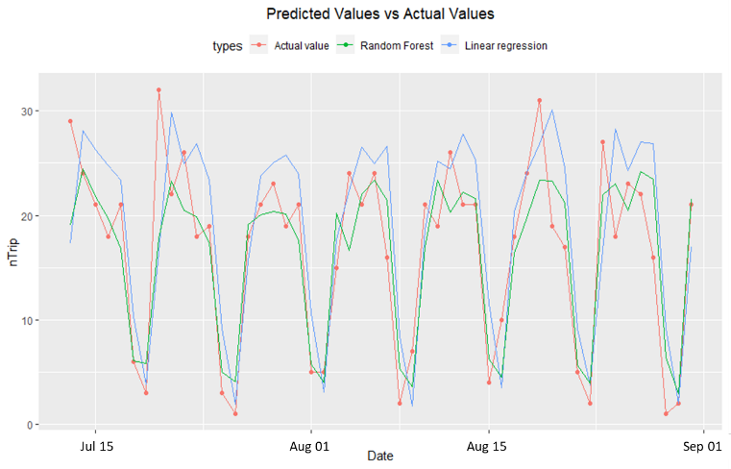

In addition, comparing the predictiveness of linear regression and random forest on number of trips from 7/13/2015 to 8/30/2015 of the stations (Broadway st. at Battery st.). Random forest provides better prediction result on weekday trips which the bike sharing system were more utilized during weekdays probably because people are using bike sharing systems as a way to commute to their final destination where bart/bus stations cannot reach directly.

A further analysis on the variable importance based on Random Forest Model, below table lists 6 most important variables which impact the number of trips made. For instance, the most important variable is the time series variable nTripYesterday.

|  |  |  |
| --- | --- | --- |
| **Rank** | **variable** | **IncNodePurity** |
| 1 | nTripYesterday | 3100877.71 |
| 2 | WeekendOrNotTRUE | 1093312.57 |
| 3 | Median.Household.Income | 494596.31 |
| 4 | Temperature.Average | 373517.08 |
| 5 | Temperature.Departure | 240590.36 |
| 6 | Business_Accommodations | 185738.56 |

|  |  |
| --- | --- |
| **Model** | **OSR2** |
| Linear Regression | 0.6838 |
| CART | 0.8222 |
| Random Forest | 0.8376 |
| Ensemble Learning | 0.8143 |

Comparison of No of trips and Day (Weekend/Weekday) (scatterplot)

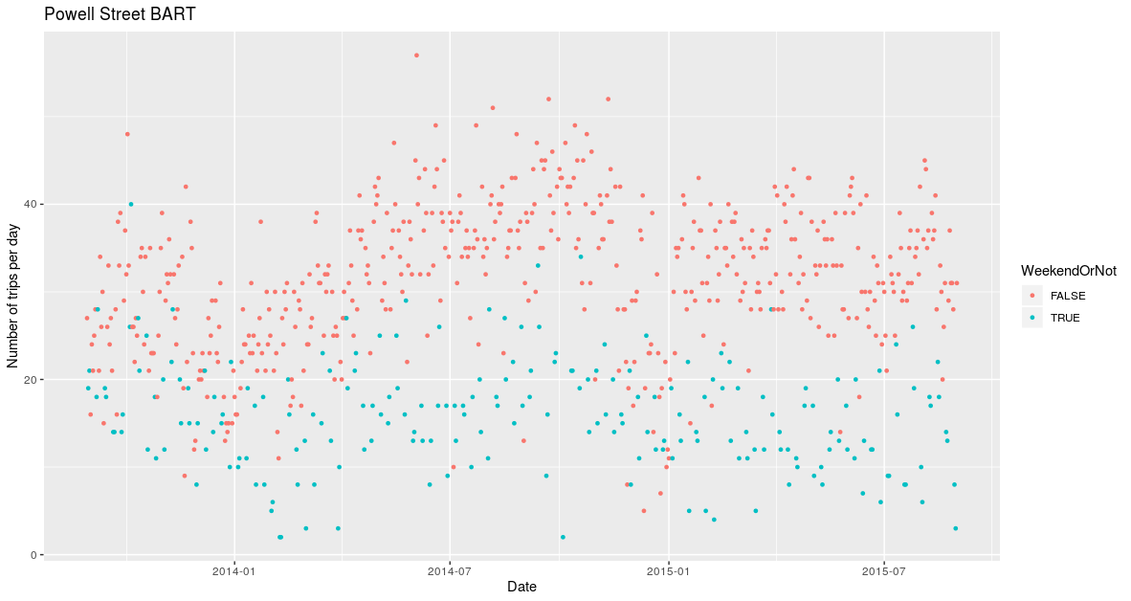

As seen in the table, Weekend and Weekday ranks second in depicting the number of trips being made.

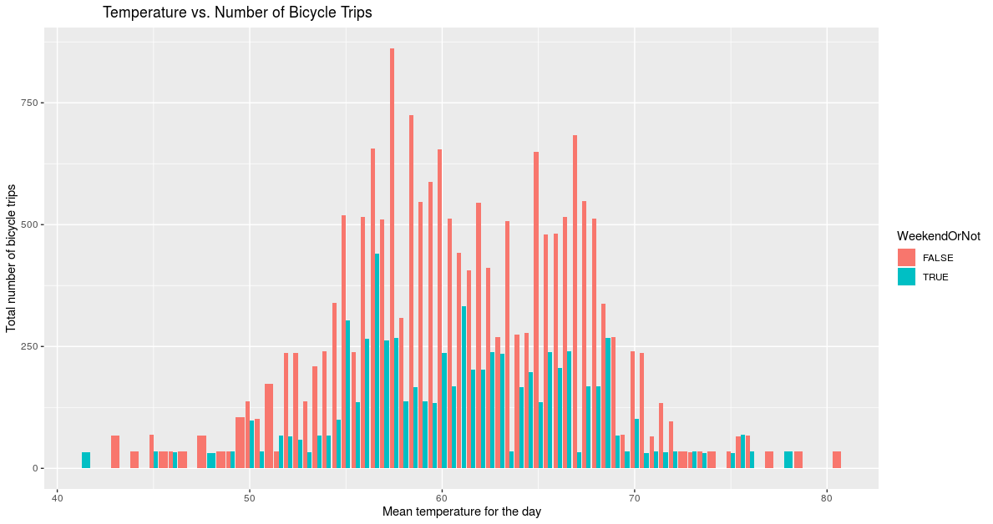

The following plot highlights 2 of the major factors: Weekend and mean temperature influencing the number of trips.

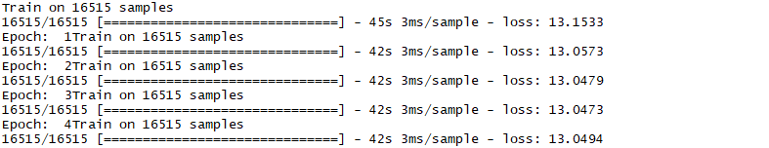

A basic LSTM model has been implemented with the following parameters: Batch size=3, Time Step=1 and single hidden layer. It is observed that LSTM model is overfitting the data and desired results are not obtained hence we conclude that it's not a suitable method for predicting the number of trips. Hence in order to incorporate LSTM techniques, we need to have large amount and more complex data to run to get suitable results.

Data Visualizations:

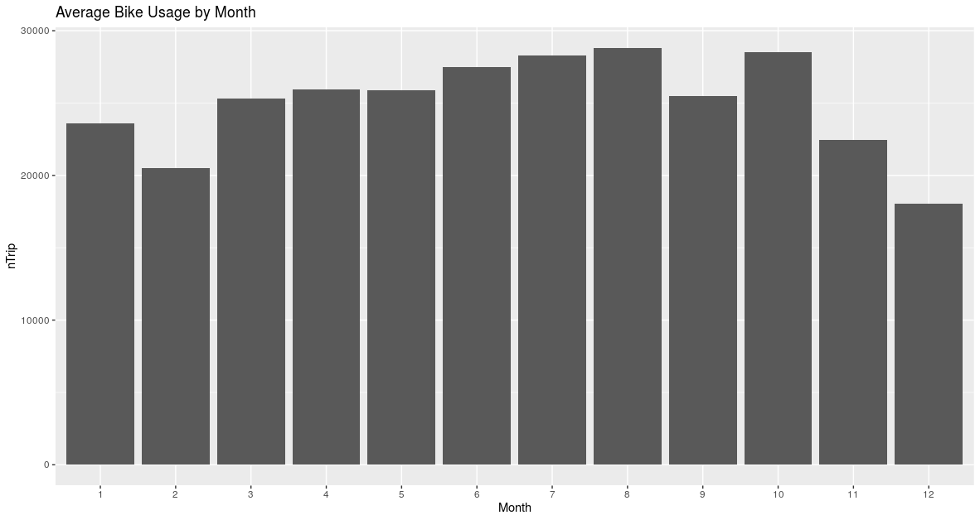

Average No of trips Monthly No of Bicycle Trips according to Time of the Day

**Appendix I - Data source:**

1. San Francisco bike sharing trips  
   <https://www.kaggle.com/benhamner/sf-bay-area-bike-share>
2. Map of Registered Business Locations  
   <https://data.sfgov.org/Economy-and-Community/Map-of-Registered-Business-Locations/ednt-jx6u?fbclid=IwAR3txwBNX4YjwSXVoWPLwdkf1DJdUylAEJXu0GnPP9VlqlzpXLTFE1gSTg0>
3. Recreation and Parks Properties  
   <https://data.sfgov.org/Culture-and-Recreation/Properties/xri9-pfud>
4. Bus Stops in San Francisco  
   <https://data.sfgov.org/Transportation/SFMTA-Transit-Stop-and-Schedule-Data-GTFS-format-/2qyp-77cq>
5. Weather data in San Francisco  
   <https://www.wunderground.com/history/monthly/us/ca/san-francisco/KSFO/date/2014-8?fbclid=IwAR07ls7NJTqBDISO2ZrHiI-V-hB6QNuBF9Rw1yEaKY-5SMqknQheUyhch8E>
6. Demographics and statistics of zip code  
   <https://www.unitedstateszipcodes.org/>
7. US Zip Code data

Unitedstateszipcodes.org

**Appendix II - Data Dictionary**

|  |  |
| --- | --- |
| **Feature** | **Definition** |
| end_station_id | The end station ID that a bike trip finishes |
| nTrip | Total number of trips made in a specific day |
| Temperature.Maximum | Maximum temperature of a day |
| Temperature.Minimum | Minimum temperature of a day |
| Temperature.Average | Average temperature of a day |
| Temperature.Departure | Departure of the average temperature from the 30-year mean temperature for the day. |
| HDD (Heating Degree Day) | A measurement designed to quantify the demand for energy needed to heat a building. It is the number of degrees that a day's average temperature is below 65o F (18o C), which is the temperature below which buildings need to be heated. |
| CDD (Cooling Degree Day) | A measurement designed to quantify the demand for energy needed to cool buildings. It is the number of degrees that a day's average temperature is above 65o F (18o C). |
| dock_count | Total of docking port in a particular station |
| Zipcode | The zip code of the end station located at |
| Median.Household.Income | Median household income of the zip code that end station resides in |
| Median.home.value | Midian home value of the zip code that end station resides in |
| Population.Density | Population density of the zip code that end station resides in |
| Population | Population of the zip code that end station resides in |
| Number.of.people.using.bicycle | Number of people using bicycles of the zip code that end station resides in |
| total_bus_stops | Number of bus stops within 400 meters radius form the bike station |
| total_parks | Number of parks within 400 meters radius form the bike station |
| Business_Accommodations | Number of registered businesses within 400 meters radius form the bike station. Different business type is classified using North American Industry Classification System (NACIS) code description. |
| Business_Administrative_Support_Services |
| Business_Arts_Entertainment_Recreationn |
| Business_Certain_Services |
| Business_Construction |
| Business_Financial_Services |
| Business_Food_Services |
| Business_Information |
| Business_Insurance |
| Business_Manufacturing |
| Business_Multiple |
| Business_Private_Education_Health_Services |
| Business_Professional_Scientific_Technical_Services |
| Business_Real_Estate_Leasing |
| Business_Retail_Trade |
| Business_Transportation_Warehousing |
| Business_Utilities |
| Business_Wholesale_Trades |
| WeekendOrNot | Identify the day if it is weekend or not |

### Appendix IV – Code

(refer to the next page)

1. SFMTA bike sharing system wide activity data: <https://stats.sfmta.com/t/public/views/FordGoBike/BikeShareSystemwideActivity?iframeSizedToWindow=true&%3Aembed=y&%3AshowAppBanner=false&%3Adisplay_count=no&%3AshowVizHome=no#3'>
2. Locations based data were calculated by geographic distance calculated by the data obtained from dataSF (<https://datasf.org/opendata/>) using additional Python code written. Note that since the distance is relatively short, we approximated by straight line distance of 400m (3-4 blocks) radius from bike stations.